CHART TYPE | TEMPLATE ESSAY
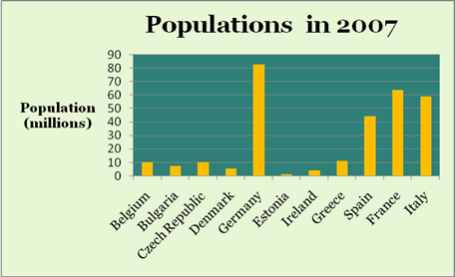 | INTRODUCTION  The bar graph shows the __________ of various ______ in the year ____.  TREND 1  The ____ with the largest _____ is _____, with over _____ whereas _____ has the smallest ____, as little as _______.  TREND 2  Apart from ____, the largest _____ are ___, ___ and ___ with ____ ranging from about ___ to ___.  CONCLUSION  Together, the ____ largest ____ account for over ____% of the _____ shown.
PIE CHART | INTRODUCTION  1. The pie chart is about ______. It is divided into ____ parts. It is taken from _______.  2. The pie chart illustrates ______.  TREND 1  The largest # of _____. There are ____.  The second largest # of ______. There are ____.  TREND 2  The chart shows that _____ have only ____ making it the lowest.  CONCLUSION  Overall, _____ accounts for the ______.  OTHER USEFUL PHRASES:  1. Having a definite _____ accounted for __% of ____. Another major influencing ___ was ____. However, interestingly, only a small ____ left for this.
Re-Tell Lecture | The lecture provides a brief information about ______. According to the speaker, he/she said ________.
Essay | INTRODUCTION  Many people _____. Other people, however, ____. This essay will examine whether _____ or whether _______.  FIRST ARGUMENT  There are several arguments for ______. First of all, _____. A second point is that _______.  SECOND ARGUMENT  CONCLUSION  In conclusion, ___________.
INTRODUCTION | The bar graph shows ____  The graph illustrates ____  The graph represents ____  The table indicates ______  The graph reveals _______  It is clear from the graph/table ________  It can be seen from the graph/table _______  As the graph/table shows, ______  As is shown by the graph/table, _______  As illustrated by the graph/table, _______
FIRST TREND | By far the largest increase is _______
SECOND TREND | ____ and _____ has the second largest increases showing

