Introduction | The graph shows…
 | Overall,…
Trend 1 | _____ increased sharply over the period  _____decreased sharply over the period  By far the greatest increase is/happened in _____  The most obvious trend in the graph is that _____
Trend 2 | ____ and____ have the next largest increase / decrease showing _____
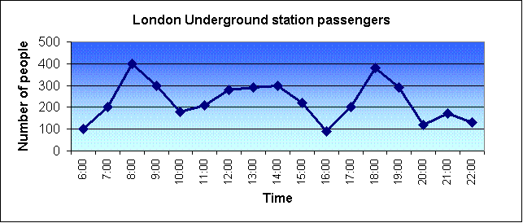 | The graph shows the fluctuation in the _______ over the ______.  Trend 1  Trend 2  Trend3  Overall, the diagram shows that the ________.
Movement (Verbs): Up | Rose  Went up  Increased  Grew  Shot up  Surged  Rocketed
Movement (Verbs): Down | Fell  Declined  Dropped  Decreased  Sank  Went down  Plunged  Plummeted
Adverbs and intensifiers | slightly  a little  a lot  sharply  suddenly  steeply  gradually  gently  steadily
No Movement: (Verbs with Adjectives, Verbs) | remained steady  were unchanged  did not change  remained constant  remained stable  stabilized
Tops and Bottoms | reached a peak  peaked  reached their highest level  fell to a low  sank to a trough  reached a bottom

