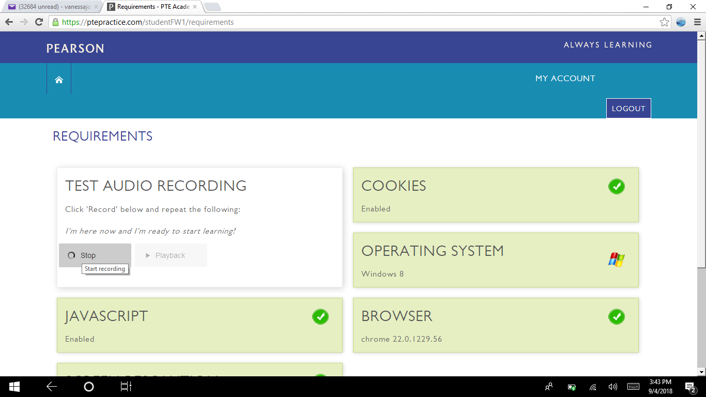

I cant stop the recording. I cant play it back