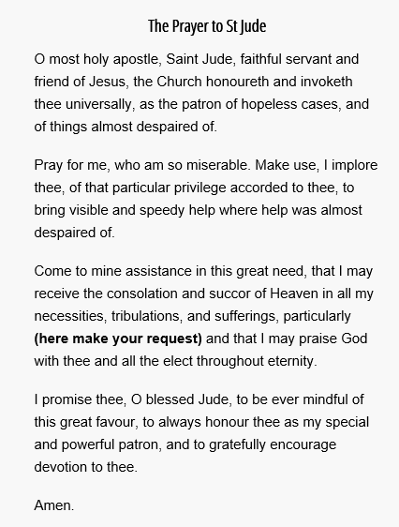
St. Jude, pray for us and all who honor thee and invoke thy aid.
(Say 3 Our Father’s, 3 Hail Mary’s and 3 Glory Be’s after this) Pray for 9 days for your novena.

(Pray Our Father, Hail Mary and Glory Be)

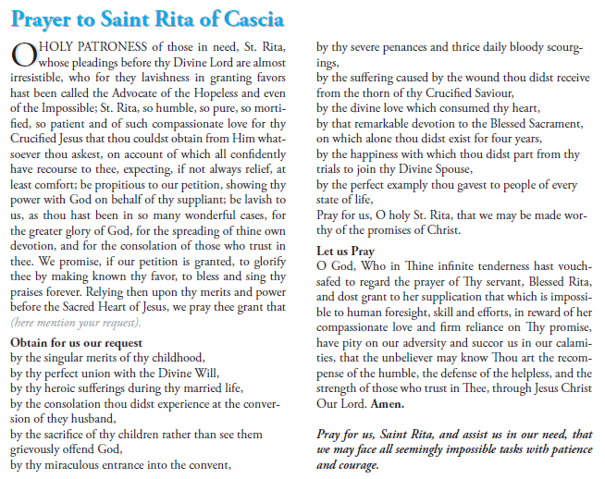
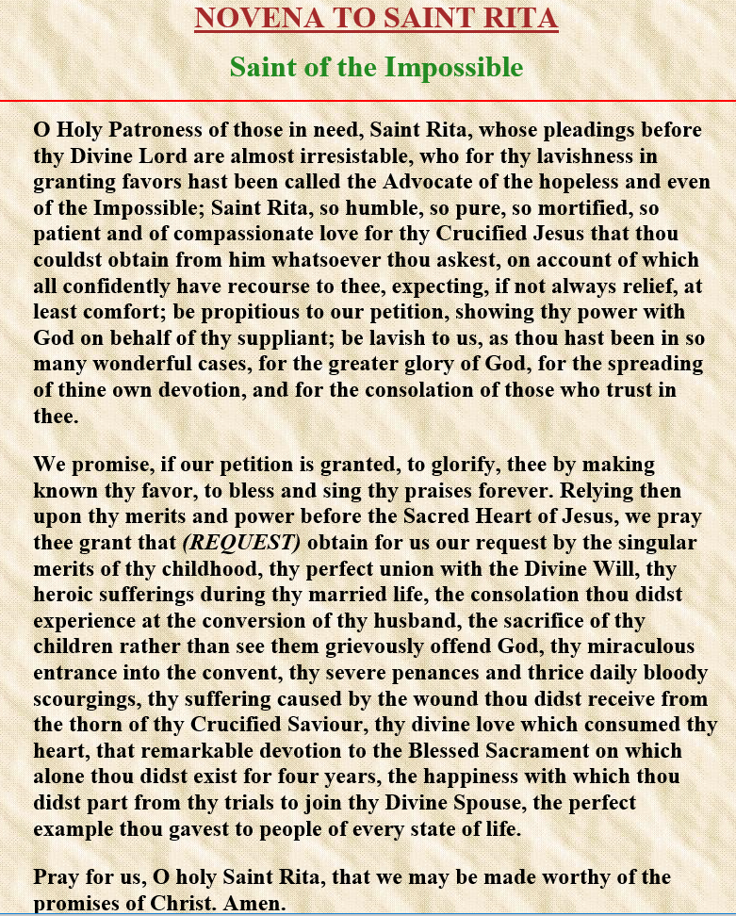

And also pray to St. Joseph
