CAREER EPISODE 2 : As a Facilities Lead Mechanical Engineer at SunPower Philippines Manufacturing Ltd. (SPML) Batangas Solar Plant, Philippines

INTRODUCTION

CE 2.1 In September 2007, I was hired by SunPower Philippines Manufacfuring Ltd. (SPML) at Batangas site as a Facilities Lead Mechanical Engineer until November 2012. SPML Batangas site is a new start-up Company.This is a second manufacturing facility (Fab 2) with 330 MW capacity rating on 10 lines, comes online in the Philippines.It boasts for being the first ever plant in the Philippines that manufacture solar panelsexported to other first world countries. The first manufacturing facility (Fab 1) comes online in the Philippines with 4 lines.

BACKGROUND

CE 2.2 The Power Plant is unique and designed to cater 10 production lines. And one of the major challenges being faced by the plant is the quality of raw power within the site and availability of treated output water (RODI–Reverse Osmosis De-ionized). I was then managing my 4 direct facilities technician in scheduling maintenance on a quarter basis and ensure all mechanical equipment parameters are within operational specification limits.

CE 2.3 I received comprehensive trainings conducted by HUNT-AIRfor HVAC aspects of the huge capacity make-up air units (MAU’s), TRANE for both water-cooled and air-cooled Chillers, and ATLAS COPCO for bigger capacity air compressors. It also includes attending to and witnessed commissioning of various mechanical equipments at the Utility Plant and Production ramp-up expansion lines.

Figure 2.1: SPML-FAB 2 FPIP, Batangas, Solar Manufacturing Plant
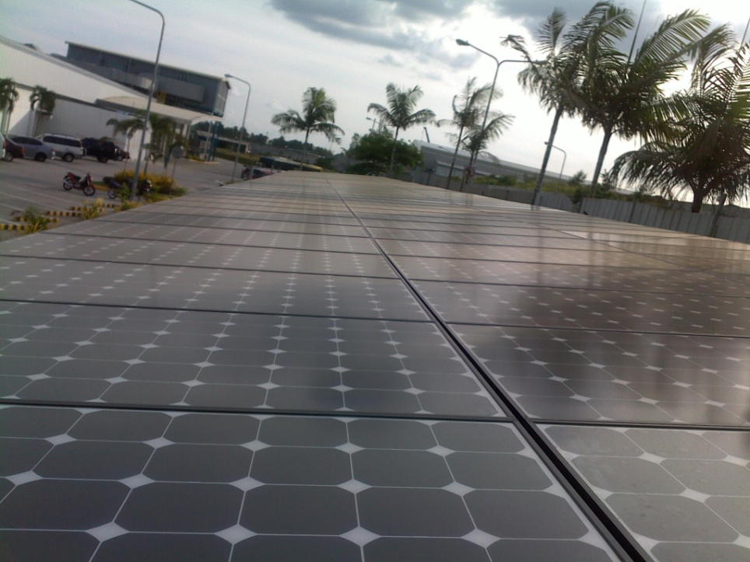

CE 2.4 Below is the Organizational Chart of Facilities Department at SPML Fab 2 Batangas site:

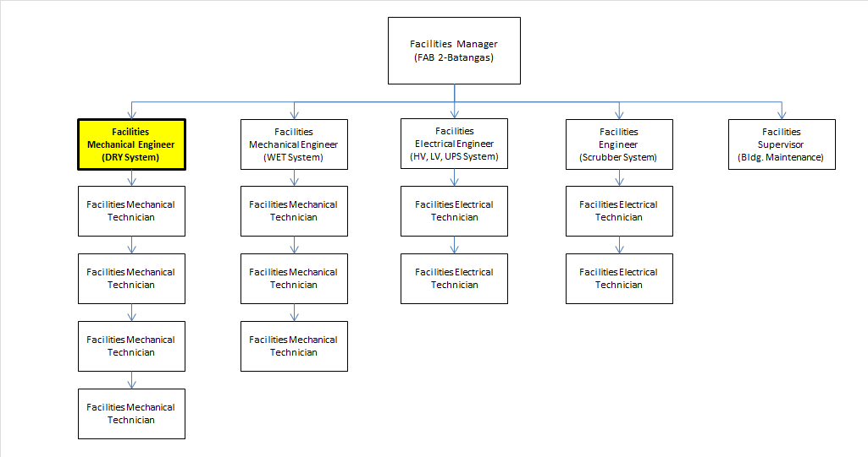

CE 2.5 In November of 2007, SPML held an assessment among all facilities engineers which is pertaining to the Utility Plant process flow, basic calculations and configurations. One of the advantages I have is that I can effectively explain well the HVAC processesfrom Chillers; Cooling Towers down to AHU’s serving production lines. Having obtained a good reputation in the said assessment thus; I was selected to represent for anEngineering Summit whereas all plant sites are invited to present a technical theme paper for improvement, savings or new processes or techniques that can be recognized world-wide. I was one of the finalists and got 2nd place in presenting the “Chiller Ball Technique” maintenance innovation summit. This is a technical presentation on how a Chiller unit using a sponge-like soft balls inserted within the condenser tubes could be maintained even during operation mode. The technical presentation was recognized by department managers including American judge panelists and was a potential candidate study for annual plant savings among other department presenters.

CE 2.6 To carry out the above task, I was responsible to do and perform the following;I lead as mechanical engineer in developing programs in driving cost reduction and zero plant downtime.I was in charge foroperation and maintenance managing in ensuring mechanical equipment are being in good and sound condition continuously undisrupted at all times.I provided technical support and technical aspect of the HVAC equipment regarding best known methods or practices in the field or industry in compliance to the mechanical engineering codes of the Philippines. I designed and developed spare parts and tools management in coordination and supervision with handled facilities technicians.I lead andconductedregular SPC (statistical process and control) meetingsto daily check possible out of control parameters for critical equipment which may affect product quality such as temperature and humidity, pressure dew point, water conductivity and other utilities.

CE 2.7 Assuming the responsibilities of a Lead Mechanical Engineer in a new start-up Company, I took the following initiatives. Since the Solar Utility Plant entails a lot of developmental procedures, I was involved and took interest on the revision of Chillers, Cooling Towers, AHU’s Air Compressors, Vacuum Pumps, General Exhaustsystem log sheetsand I have developed the “minimum & maximum” operation limits and officially upload the document thru ourChange Management System (CMS). I listed down all the parameters of certain equipment; Chillers, Air Compressors and General Exhaust Trip Set Points, MAU Auxiliary Main Fan Alarm Points, and Auxiliary equipment such as chilled and condenser pumps Trip Set Points.

I have designed a facilities hardening system showing all the alarms and parameters set point of all the equipment installed at the BMS main control room, including general exhaust set points and vacuum pressure critical parameters. The initiative I made such as installation of mechanical backdraft dampers that I have conceptualized, installed and implemented were being recognized during power interruption which results in saving time spent by facilities technicians in responding to the facilities recovery uptime.I studied and mastered on how to interpret Trend Graph and how to use SCADA(System used in Instrumentation &Control System); Alarm checking, Sequence of Events,Chart trend, etc.Having to deal mostly on Instrumentation in the Utility Plant, I took the initiative to do a self-study on interpreting the Instrumentation Symbols and Diagrams. I learned the Logic Symbols and interpretations as an added extra to my position, this would later on be helpful to my advantage since I can now interpret how a certain control valve will react and I can efficiently distinguish the discrepancies on certain events or troubles on the process flow. I have prepared as well the Work Instructions for the Air Handling Unit & Make-Up Air Unit basic operations including Cooling Towers and auxiliary chilled and condenser water pumps; Mechanical Scrubber Fans & General Exhaust Fans Test and Vacuum Pump operation & maintenance.

PERSONAL ENGINERING ACTIVITY

CE 2.8 On September 21, 2010,there was a major air compressor tripping incident that was due to re-occurring deep power fluctuations.I reviewed the process hot water configuration of the plant’smechanical piping system. The CDA system is holistically designed to unit auxiliary N+1 or redundancy air compressors with same capacity rating to provide 100% back-up to the Solar Manufacturing Plant. These available two redundant standby air compressors have PHW valves, each can be manually be turned on by technicians should the need arise. Each of these 500 kW air compressors arecentrally connected to the Chiller’s cooling water exit of the Cooling Tower. In my configuration analysis, there was no Uninterrupted Compressed Air System (UCAS) comprehended in the original design when the plant was commissioned. And therefore, one miss of re-starting the standby air compressor will definitely have an impact to compressed air supply. Manual turn-on of these standby units by on-duty technicians is a wide gap which has to be addressed immediately by either automating the system by auto-turn on if viable or other mechanical means possible. I investigated the problem utilizing first the Root Cause & Corrective Action (RCCA) method. I sequentially use the Cause and Effect Methodology and incorporated my knowledge about the possibility of suggesting UCAS on the CDA System to further support my investigation. The Series of Cause I have interpreted were as follows:Air CompressorNo.3 was shut down and consequently, a delay in turning on standby air compressor No.4 was not immediately been established as a consequence as facilities control room has no means to monitor any shut-off air compressor unit beside the manual eye of support technicians. In order to address such gap, the outsource support personnel were stationed inside the compressor room at all times with 2 sustaining shifts for the mean time to contain the problem first.

The OEM vendor went to me as I had requested to check the possibility of incorporating UCAS to our CDA system. However, the assessment turned out that due to the huge capacity of the compressor motor, there should be a separate air tank vessel coupled with booster air compressor capable to withstand at least 1.5 minutes of sustained air reserve. Initially, an automatic restart after voltage fluctuation (ARAVF) was first suggested to arrest the perennial problem. But technically found to be harmful as it may damage the motor during intermittent hits to power fluctuation, reason for its project decline. The conclusions made by the collaboration between me, electrical engineer colleagues, our manager as well as ATLAS COPCO, led us to pursueUCAS project.Upon placing a device called the power quality analyzer mounted on the electrical panel terminals of the air compressor motor provided by ATLAS COPCO, we had then established an objective data showing how power fluctuation affects our air compressor motor breakdown. We then saw for the first time the graph trend of voltage surging during power hits most especially deep ones.Fast transfer of the redundant air compressor unit was not fully guaranteed to automatically restart due to the limited resource available as the air compressor motor was still pronefor possible winding damage brought by successive power dips. On the other hand, as voltage plays one of the major roles in keeping the air compressor running continuously beside low ambient temperature surrounding the motor, we then continue the practice of placing the on-line monitoring system of voltage located inside facilities control room to our advantage.

CE 2.9 The simultaneous tripping of the operational 400 kW air compressor and its redundant 500kW air compressor unit led to the drop of CDA Header central air pressure and temperature loss of the Process Hot Water (PHW).This is due to the manual gradual adjustment increase of after cooler valvesmade between volume CFM (cubic feet per minute) generation demand versus hot water production. This was the first time I was able to clearly identify the problem cause while I was trying to take my set Plan of Actions:Someof our facilities colleagues were not receptive to my suggestion based on my interpretation toplace UCAS(Uninterrupted Compressed Air Supply)in the CDA system as they think it would be too costly and difficult to install. I was already coordinating with ATLAS COPCO design group to send out technical feasibility and on-site checks but the response was slow. My Operations Manager needed more time for corporate headquarters budget approval as well as technical review. The suggestion I made materialized as top management recognized that FAB 2 Batangas plant cannot afford long plant shutdown from a CDA failure considering expansion projects forecasted in the next few years. I was then proceeded to prepare and execute the approved project bids and invited two major contractors to join in the supply and installation of UCAS project.

CE 2.10 Despite the challenges, I did not still give-up to help resolve the perennial problem on hot water constraint. I recalled from ATLAS COPCOpast trainings and all the inquiries I made from them that I took note of. I conducted Failure Mode & Effect Analysis Problem solving based on my Engineering practices and Statistical Process and Control Methods and contextual knowledge. I took the following action steps in order to contain and prevent further problems.I tried saving the Process Hot Water Header pressure by gradually reducing after cooler valve out the temperature reduction to compensate loss on lines 5 & 6 production hot water requirements without sacrificing potential shutdown on air compressor.Immediately during the rise of hot water temperature as a consequence, the thermostatic expansion valve did not open 100%. I advised all technicians and shift engineers to standby for Cooling Towers rise in thecooling water discharge temperature, the ambient air temperature of the surrounding motor of air compressor and the increased motor ampere as we install a power quality analyzer and thermal imaging device mounted for almost a month. I advised the sub-contracted technicians and shift duty technicians to make adjustments necessary at the balancing valve of the Cooling Towers directly in order to maintain the cooling water discharge temperature requirement not to exceed the maintaining temperature of 45-50°F and lock this temperature within rangeat the Power Plant. In doing so, we had maintained this temperature lockdown for two weeks and it yielded positive results. The initial attempt to manually adjust at the balancing valve was successful due to the restricted setting. The facilities techniciansand ATLAS COPCO Maintenance verified the practice and proved that we can manually control the temperature in order to allow the required cooling water temperature. This gave confidence to top management to justify proceeding with the design of UCAS.

CE 2.11 During the quarter, the Facilities Manager was confident on the progress of my action plans. He gave his full trust on me with the team to lead the situation. Thus, I commanded and the mechanical engineering task of firming the received technical and budgetary bids on the UCAS and CDA Room ventilation project.

CE 2.12 Approximately after 2 successive quarters, the design requirement of having one 320 standard cubic feet per minute booster pump and relatively one 13 cubic meter air receiving tank at 700 psig minimum at 44 minutes air refill time capable of withstanding of at least 105 seconds holding time after a power shutdown scenario was realized. The objective of providing a supported technical design of 11,000 cubic feet per minute volume was realized at 90 psig. There were also installed new and four huge wall mounted exhaust fans placed on the walls of CDA room which gave sufficient ventilation thus, lowering hot temperature build-up of at least 3-5°C reduction improvement.

CE 2.13 The project initiative that I had led was successful. All of my technical analysis and interpretations were involved in the RCCA, SPC & FMEA formed with the rest of the team’s weekly brainstorming. The management then on, followed my recommendation that eventually helped in case ofpower tripping occurrence. The operations had set an Automatic Valve Adjustment Protocol in CDA Plant system. At my suggested maintaining temperature limit as well as the UCAS system. Withan automatic Emergency booster air compressor of 320 CFM installed coupled with an 13 cubic meter air receiver tank capacity for the sole purpose of providing back-up air in case of power event scenario.Recognition was also given to me as evidenced by additional credits given to my quarterly evaluation accomplished by hitting the objectives, planning and execution thus, receiving additional bonus reward in the year-end key initiatives personal assessment.

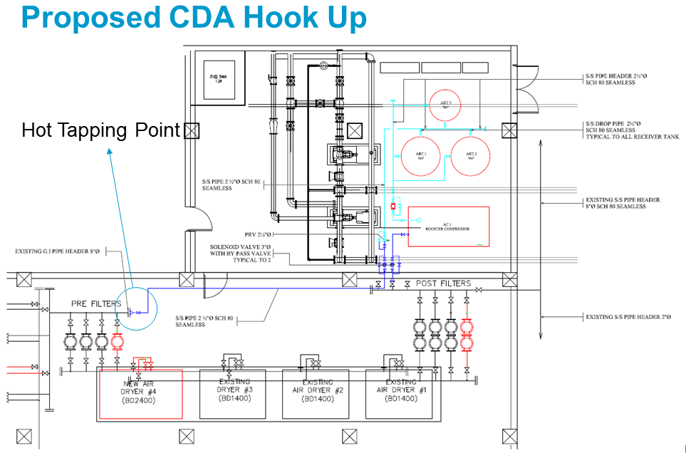

C. SUMMARY

CE 2.14 The air compressor breakdown has tested my character and my driving capabilities. My former plant experiences I had in my previous plant expertise and exposure had put me in openly suggesting ideas which are not conventional but was proven viable if worked closely together as one team. I am thankful that it had occurred during my work stint, for it not only tested my tenacity& flexibility as a lead mechanical engineer but the idea of bringing back into operation the Manufacturing Solar Plant is something that I am very proud of.

